10. Scenario: You are working on a data visualization project and need to create basic plots using Matplotlib. You have a dataset containing the monthly sales data for a company, including the month and corresponding sales values. Your task is to develop a Python program that generates line plots and bar plots to visualize the sales data.Question:1. How would you develop a Python program to create a line plot of the monthly sales data?2: How would you develop a Python program to create a bar plot of the monthly sales data?
import matplotlib.pyplot as plt
months = ['Jan', 'Feb', 'Mar', 'Apr', 'May']
sales = [100, 150, 120, 180, 200]
plt.subplot(1, 2, 1)
plt.plot(months, sales, marker='o')
plt.title('Line Plot')
plt.subplot(1, 2, 2)
plt.bar(months, sales)
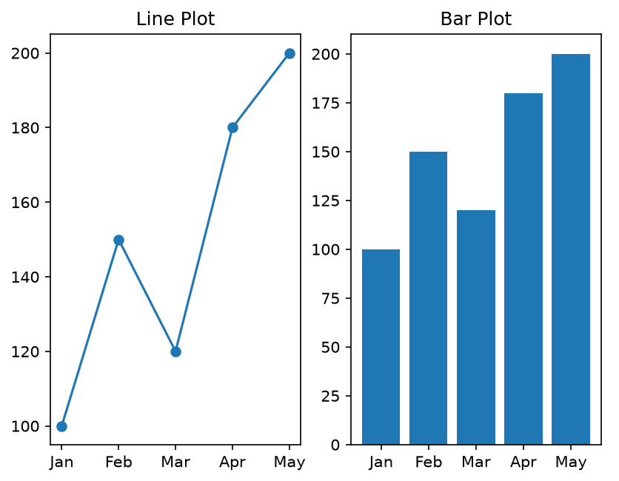

11. Scenario : You are a data scientist working for a company that sells products online. You have been tasked with creating a simple plot to show the sales of a product over time.Question:1. Write code to create a simple line plot in Python using Matplotlib to predict sales happened in a month?2. Write code to create a scatter plot in Python using Matplotlib to predict sales happened in a month?3. Develop a Python program to create a bar plot of the monthly sales data.
import matplotlib.pyplot as plt
months = ['Jan', 'Feb', 'Mar', 'Apr', 'May']
sales = [100, 150, 120, 180, 200]
plt.subplot(1, 3, 1)
plt.plot(months, sales)
plt.title('Line Plot')
plt.subplot(1, 3, 2)
plt.scatter(months, sales)
plt.title('Scatter Plot')
plt.subplot(1, 3, 3)
plt.bar(months, sales)
plt.title('Bar Plot')
plt.show()
plt.show()
plt.show()
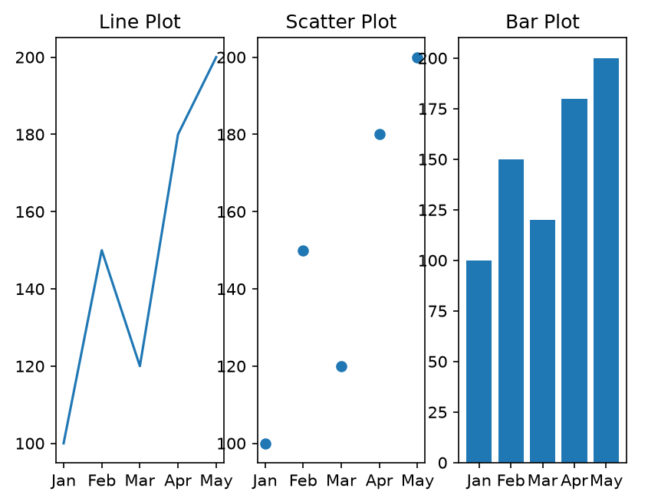
12. Scenario: You are working on a data analysis project that involves analyzing the monthly temperature and rainfall data for a city. You have a dataset containing the monthly temperature and rainfall values for each month of a year. Your task is to develop a Python program that generates line plots and scatter plots to visualize the temperature and rainfall data.Question:1. Develop a Python program to create a line plot of the monthly temperature data.2: Develop a Python program to create a scatter plot of the monthly rainfall data.
import matplotlib.pyplot as plt
months = ['Jan', 'Feb', 'Mar', 'Apr', 'May']
temp = [25, 28, 30, 32, 29]
rainfall = [20, 35, 15, 50, 40]
plt.subplot(1, 2, 1)
plt.plot(months, temp, marker='o')
plt.title('Temperature')
plt.subplot(1, 2, 2)
plt.scatter(months, rainfall)
plt.title('Rainfall')
plt.show()
